**Bootstrap Examples**

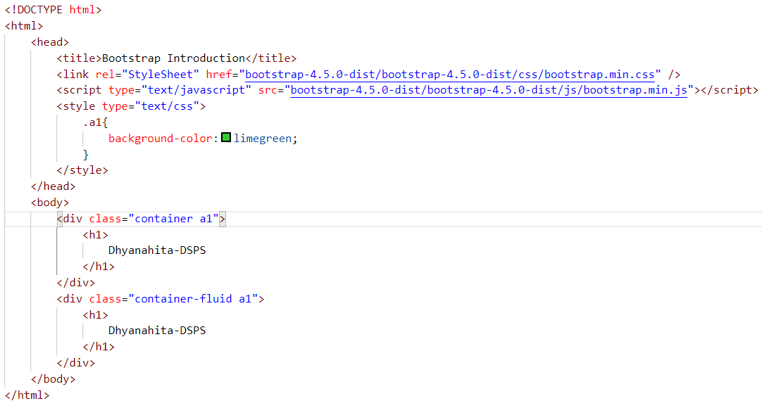

**Bootstrap Grid System**

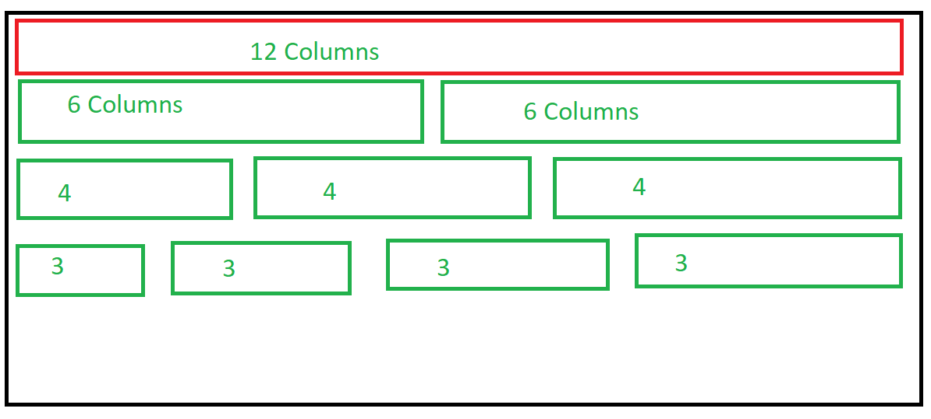

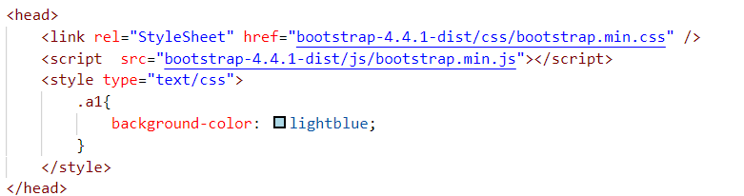

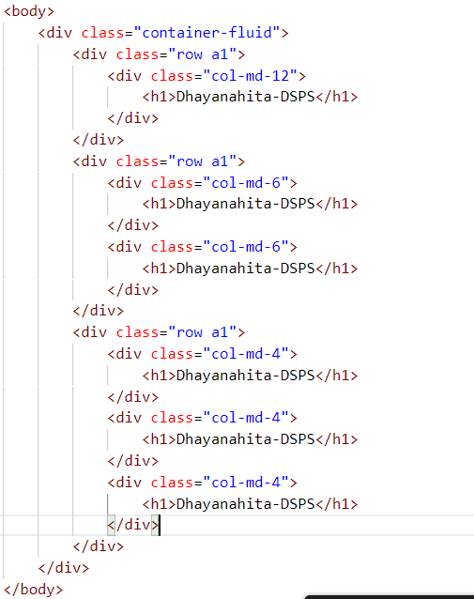

**Bootstrap Tables**

1. Table
2. Table-striped
3. Table-hover
4. Table-bordered
5. Table-dark
6. Table-dark and table-striped

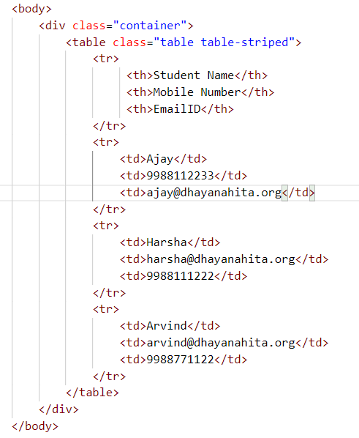

**Bootstrap Images**

1. Rounded
2. Rounded-circle
3. Rounded-thumbnail
4. Img-fluid for responsive of the images

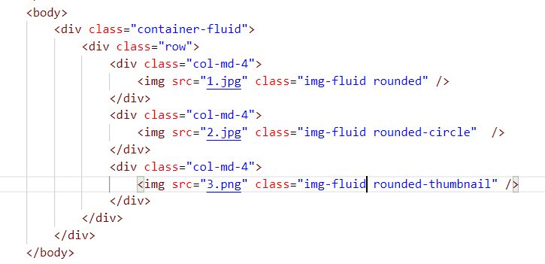

**Bootstrap Buttons**

1. Btn
2. Btn-primary
3. Btn-secondary
4. Btn-info
5. Btn-warning
6. Btn-danger
7. Btn-light
8. Btn-dark
9. btn-lg(large),btn-sm(small),btn-md(medium)

